Logistic regression can be used only to predict a binary, categorical variable. It returns a single value form 0 to 1 which indicates probability that our variable belongs to some class. It uses a maximum likelyhood method.

Logistic regression coefficients can tell us how strong is the relation between two categorical variables or between categorical and continuous variable.

Calculating coefficients for continuous variable
Let’s assume that we want to check how strong is the relation between variable ‘weight’ indicating a weight of a mouse and variable ‘obese’ indicating if a mouse is obese.

Let’s assume that f(x) is our logistic regression function. This is a ‘S’ shape function going from 0 to 1 like in the picture on the left hand side. We can change it into a straight line function g(x) on the right hand side, where g(x) = log(f(x) / (1 - f(x))) = ax + b.
Then f(x) = e^(g(x)) / (1 + e^(g(x)))

The graph on the left hand side has on the y axis probability of being obese. The graph on the right hand side has on the y axis lod(odds of being obese) = log(p / (1 - p)), where p = probability of being obese.

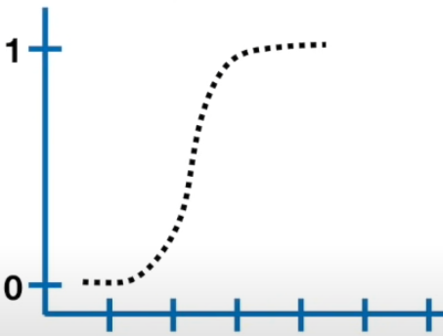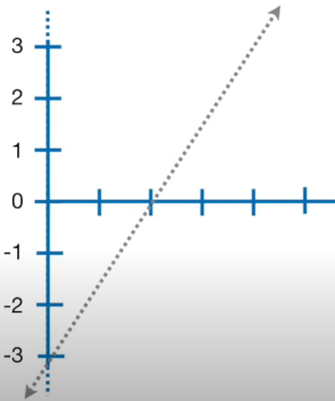

If our ‘x’ paramter is a variable called ‘weight’ then logistic regression parameters will be written in this way: 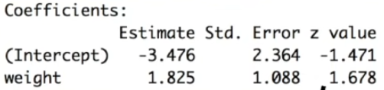
The ‘b’ parameter of g(x) function corresponds to the ‘Estimate Intercept’ parameter and ‘a’ parameter of g(x) function corresponds to the ‘Estimate weight’. The ‘a’ parameter tells us how much the weight variable increases log(odds of being obese).

Calculating coefficients for categorical variable
Let’s assume that we want to check how strong is the relation between variable ‘mutant’ which indicates if a mouse has a mutated gene and variable ‘obese’ indicating if a mouse is obese.

Let’s assume that this is our dataset:
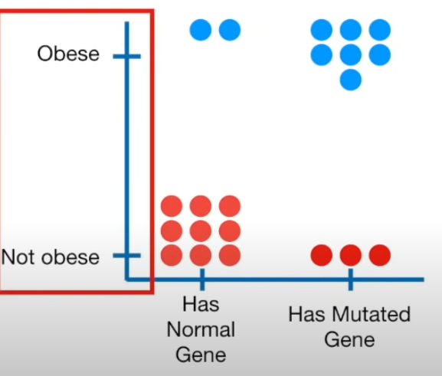

At first we transform the y axis from probability of being obese to the log(odds of obesity):
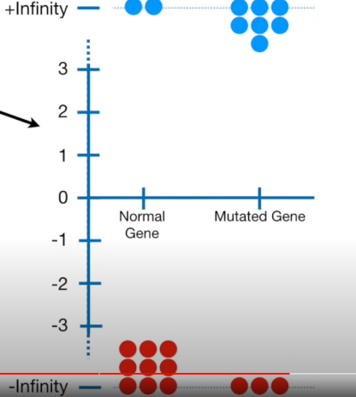

Then we calculate log(odds of obesity) for the mouse with the normal gene. This calue will be called log(odds gene_normal):
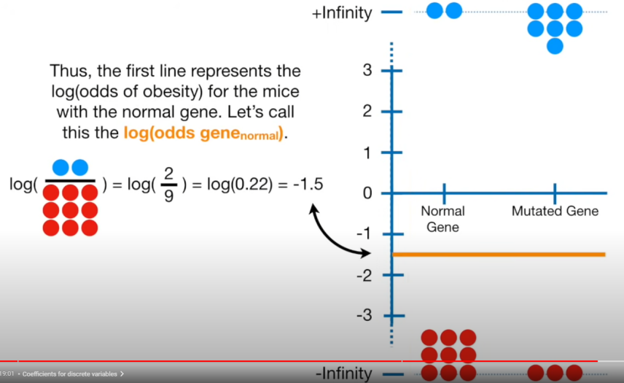

Then we do the same for the second group and we obtain the value log(odds gene_mutated). Then using those two values we obtain a formula:
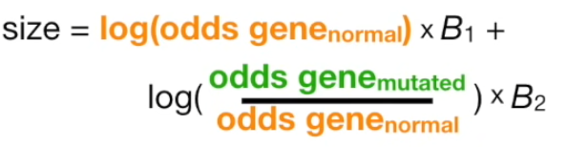

The first parameter  is so called intercept and the second one 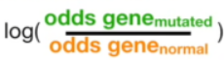 is a paremeter corresponding to the variable ‘mutated’ and it tells us how much having a mutated gene increases or decreases the odds of being obese.

Maximum likelyhood method
This is a method used to train a model. If we want to predict y given features x1, ..., xn, this method is maximizing a probability of observing y given x1, ..., xn in our dataset.

Let’s assume that we want to predict if a mouse is obese given its weight. This is our dataset:
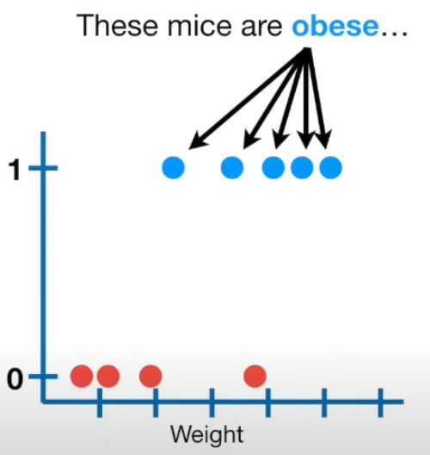

And our model will look like this:

Where on the x axis we have a mouse weight and on the y axis we have a probability of being obese. In order to create it firstable we create a new y axis where values are log(odds of obesity). We draw a line and project on it data points:
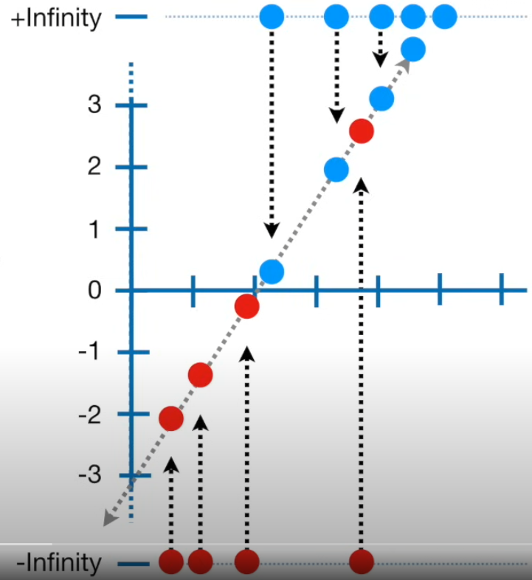

In this way we assign a log(odds) value to each point. Then we transform those log(odds) to probabilities using this formula:
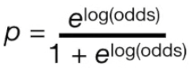
Once we have those probabilities calculated for each data point we can calculate a probability of observing our dataset by multiplying those probabilities.

Now we want to create a new line for which probability of observing our dataset will be bigger. We can use gradient descent to calculate how to change parameters of that line in order to make this probability bigger.

R^2
We can calculate R^2 and p-value for a logistic regression just like for a linear regression and interpretation is the same but formula is different.

C parameter for sklearn logistic regression

Inverse of regularization strength, higher valeus of C will cause model to have bigger coefficients values and be more fitted to training data, lower C causes model’s coefficients to be smaller and model is less fitted to the training data. Good values for C to test are powers of 10, so 0.01, 0.1, 1, 10, etc.

Solver argument for logistic regression

It’s algorithm to use for finding maximum of likelyhood.

Standarization for logistic regression

Standarization isn’t required but it can cause model to build faster (maximizing likelyhood is quicker). It is also useful when using regularization.

